CYCLE-2
1) Create 2 Activities from 1st Activity on click move to 2nd activity (Using Intent

activity_main.xml

<LinearLayout
android:id="@+id/p1"
android:layout_width="match_parent"
android:layout_height="match_parent"
android:orientation="vertical"
android:gravity="center"
xmlns:android="http://schemas.android.com/apk/res/android">
<Button
android:id="@+id/btn"
android:layout_width="wrap_content"
android:layout_height="wrap_content"
android:gravity="center"
android:onClick="click"
android:text="Click"/>
</LinearLayout>
activity_main2.xml
<?xml version="1.0" encoding="utf-8"?>
<android.support.constraint.ConstraintLayout xmlns:android="http://schemas.android.com/apk/res/android"
xmlns:app="http://schemas.android.com/apk/res-auto"
xmlns:tools="http://schemas.android.com/tools"
android:layout_width="match_parent"
android:layout_height="match_parent"
android:layout_gravity="center"
tools:context=".Main2Activity">
<TextView
android:layout_width="wrap_content"
android:layout_height="wrap_content"
android:gravity="center"
android:text="activity 2"
tools:layout_editor_absoluteX="164dp"
tools:layout_editor_absoluteY="237dp" />
</android.support.constraint.ConstraintLayout>
MainActivity.java
package com.example.sjcet.cy21;
import android.support.v7.app.AppCompatActivity;
import android.os.Bundle;
import android.view.View;
import android.content.Intent;
import android.widget.Button;
public class MainActivity extends AppCompatActivity {
Button btn;
@Override
protected void onCreate(Bundle savedInstanceState) {
super.onCreate(savedInstanceState);
setContentView(R.layout.activity_main);
btn = findViewById(R.id.btn);
}
public void click(View view) {
Opennewactivity();
}
public void Opennewactivity()
{
Intent intent=new Intent(this,Main2Activity.class);
startActivity(intent);
}
}
Main2Activity.java
package com.example.sjcet.cy21;
import android.support.v7.app.AppCompatActivity;
import android.os.Bundle;
public class Main2Activity extends AppCompatActivity {
@Override
protected void onCreate(Bundle savedInstanceState) {
super.onCreate(savedInstanceState);
setContentView(R.layout.activity_main2);
}
}Output
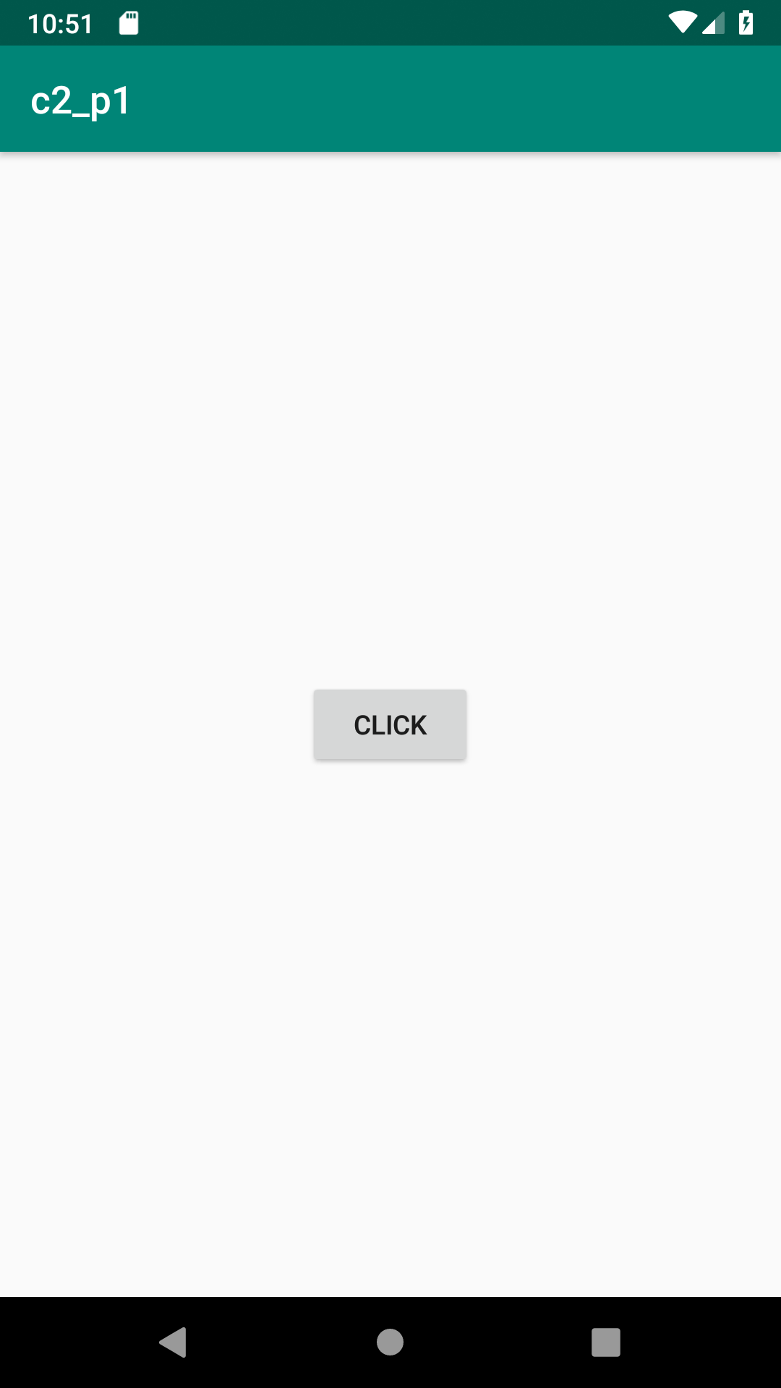

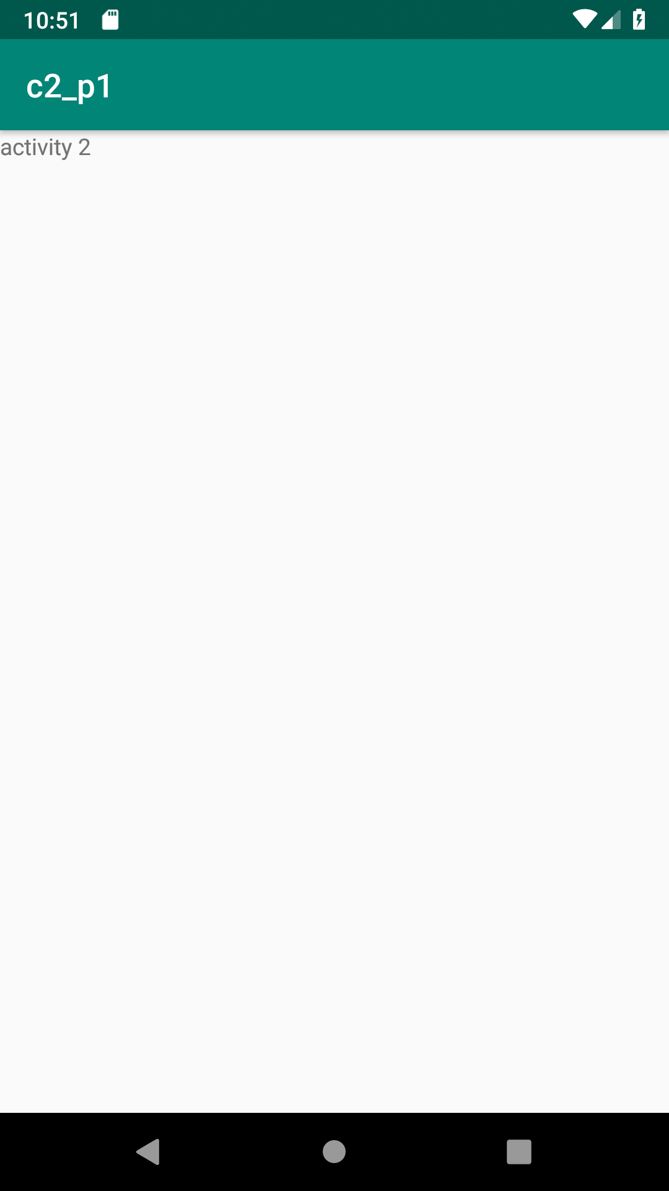

2)Create an Activity and move to facebook login page on a button click(making use of Intent).
activity_main.xml
<LinearLayout android:layout_width="match_parent" android:layout_height="match_parent"
android:orientation="vertical"
android:gravity="center"
xmlns:android="http://schemas.android.com/apk/res/android">
<Button
android:layout_width="wrap_content"
android:layout_height="wrap_content"
android:text="MOVE TO FB PAGE"
android:id="@+id/bt"
android:onClick="click"
android:gravity="center"/>
</LinearLayout>
MainActivity.java
package com.example.sjcet.program12;
import android.support.v7.app.AppCompatActivity;
import android.os.Bundle;
import android.view.View;
import android.widget.Button;
import android.widget.TextView;
public class MainActivity extends AppCompatActivity {
TextView tv1;
@Override
protected void onCreate(Bundle savedInstanceState) {
super.onCreate(savedInstanceState);
setContentView(R.layout.activity_main);
}
public void Chnage(View view) {
tv1=(TextView) findViewById(R.id.tv1);
tv1.setText("New Content");
}
}
Output

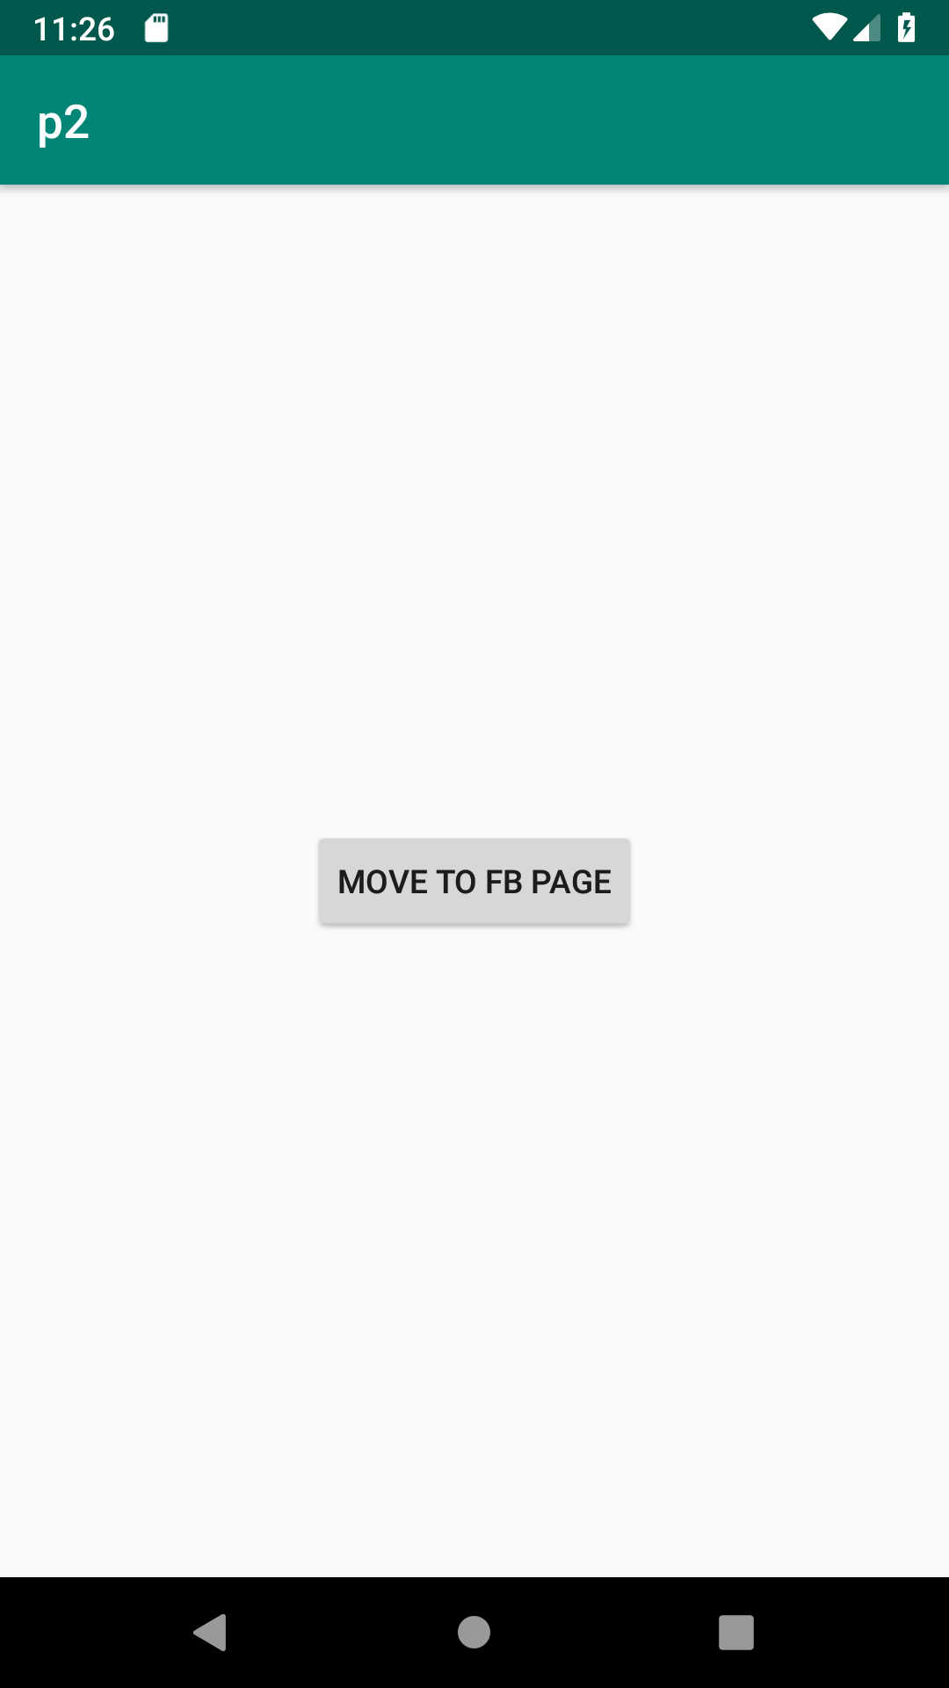

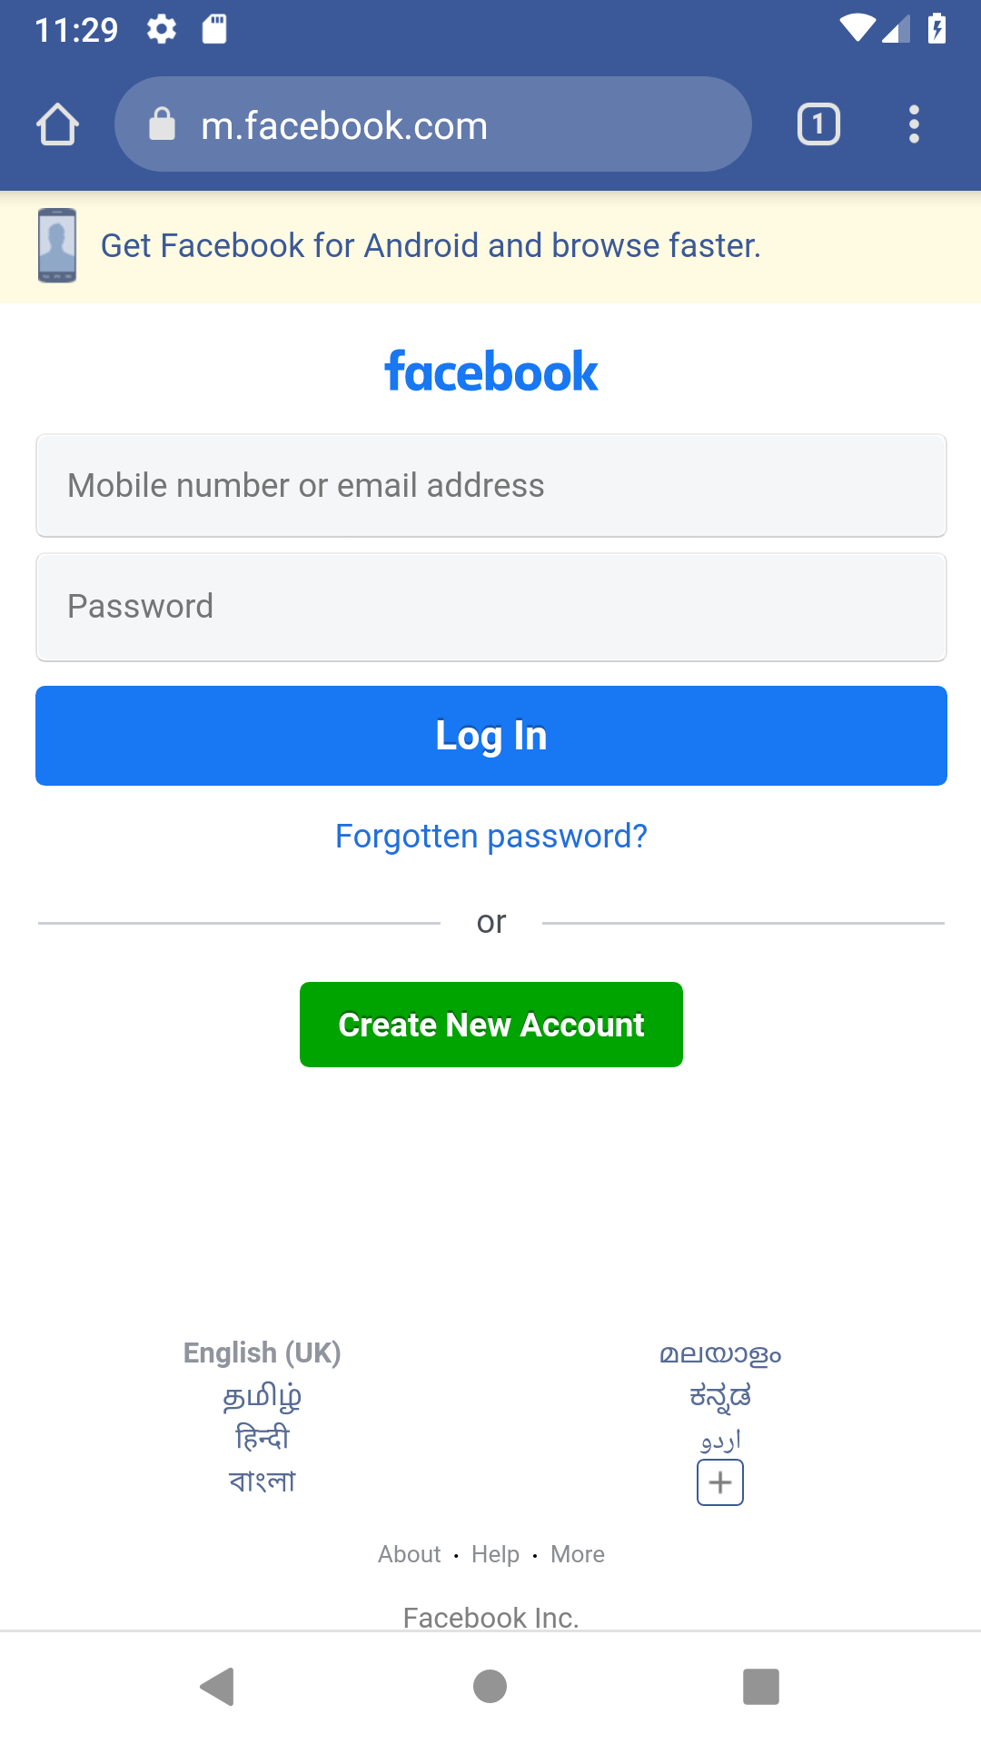

3).Read message from 1st Activity and pass it onto the 2nd Activity on a button click.
activity_main.xml
<?xml version="1.0" encoding="utf-8"?>
<RelativeLayout
xmlns:android="http://schemas.android.com/apk/res/android"
xmlns:app="http://schemas.android.com/apk/res-auto"
xmlns:tools="http://schemas.android.com/tools"
android:layout_width="match_parent"
android:layout_height="match_parent"
tools:context=".first_activity">
<EditText
android:id="@+id/send_text_id"
android:layout_width="300dp"
android:layout_height="wrap_content"
android:textSize="25dp"
android:hint="Input"
android:textStyle="bold"
android:layout_marginTop="20dp"
android:layout_marginLeft="40dp"/>
<Button
android:id="@+id/send_button_id"
android:layout_width="wrap_content"
android:layout_height="40dp"
android:text="send"
android:textStyle="bold"
android:layout_marginTop="150dp"
android:layout_marginLeft="150dp"/>
</RelativeLayout>
activity_main2.xml
<?xml version="1.0" encoding="utf-8"?>
<RelativeLayout xmlns:android="http://schemas.android.com/apk/res/android"
xmlns:app="http://schemas.android.com/apk/res-auto"
xmlns:tools="http://schemas.android.com/tools"
android:layout_width="match_parent"
android:layout_height="match_parent"
tools:context="org.HELLO WORLD.navedmalik.sendthedata.Second_activity">
<TextView
android:id="@+id/received_value_id"
android:layout_width="300dp"
android:layout_height="50dp"
android:textStyle="bold"
android:textSize="40dp"
android:layout_marginTop="20dp"
android:layout_marginLeft="40dp"/>
</RelativeLayout>
MainActivity.java
package com.example.sjcet.cyc2pgm3;
import android.content.Intent;
import android.support.v7.app.AppCompatActivity;
import android.os.Bundle;
import android.view.View;
import android.widget.Button;
import android.widget.EditText;
public class MainActivity extends AppCompatActivity {
// define the variable
Button send_button;
EditText send_text;
@Override
protected void onCreate(Bundle savedInstanceState)
{
super.onCreate(savedInstanceState);
setContentView(R.layout.activity_main);
send_button = (Button)findViewById(R.id.send_button_id);
send_text = (EditText)findViewById(R.id.send_text_id);
// add the OnClickListener in sender button
// after clicked this button following Instruction will run
send_button.setOnClickListener(new View.OnClickListener() {
@Override
public void onClick(View v)
{
// get the value which input by user in EditText
// and convert it to string
String str = send_text.getText().toString();
// Create the Intent object of this class Context() to Second_activity class
Intent intent = new Intent(getApplicationContext(), Main2Activity.class);
// now by putExtra method put the value in key, value pair
// key is message_key by this key we will receive the value, and put the string
intent.putExtra("message_key", str);
// start the Intent
startActivity(intent);
}
});
}
}

Main2Activity.java
package com.example.sjcet.cy21;
import android.support.v7.app.AppCompatActivity;
import android.os.Bundle;
public class Main2Activity extends AppCompatActivity {
@Override
protected void onCreate(Bundle savedInstanceState) {
super.onCreate(savedInstanceState);
setContentView(R.layout.activity_main2);
}
}
Output
